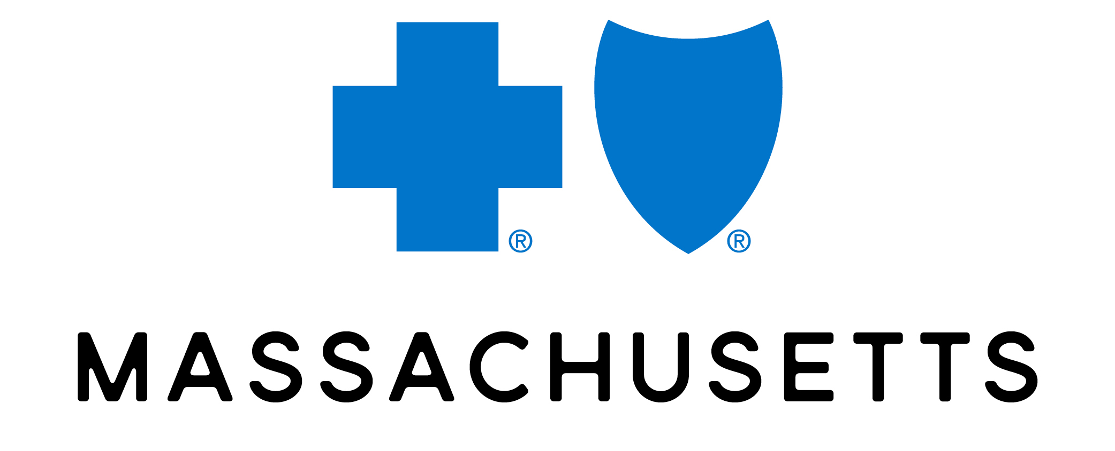

2026 Broker & Consultant Forum

Marketing strategic brief Intake (complex/moderate strategy project only)
Defining the Approach & Plan of Action: Once project scope is assessed or determined, please answer the following questions to begin building out the strategy. This should be a collaborative effort with Marketing leaders. If you have completed a Front Door Intake, you can leverage that information and evolve/update as needed. Attach any Front Door Intake documents.

Submitted by: Meg Boroyan | Submission Date: January 12, 2026
Budget: $400k | Desired Delivery Date: April 28-29, 2026

Core team | Which Marketing Teams are likely needed to support the project? (Put an X next to team name)
  Brand |  | Channel |  | Brand Compliance
  Consumer Marketing |  | Content |  | Other
  B2B Marketing | X | Creative | X | Other
  Senior Marketing |  | Events | X | Other
  Comp & Benefits |  | Project Management | X | Other
Project Overview | Describe the product, feature, service, or attribute at the core of the project. What is the company trying to achieve? ​  The biannual Broker & Consultant Forum is BCBSMA’s premier event for our most critical partners. In a market defined by rapid change, escalating costs, and complexity, brokers and consultants need more than information; they need actionable strategies. This year's forum is designed to deliver precisely that through expert-led sessions and invaluable networking opportunities/activities. These activities are crafted to foster deeper connections with our leadership and their peers, positioning BCBSMA as an indispensable partner who empowers them to succeed.
IS this related to another project? | If this is part of an existing campaign or project, please list it here.  N/A
Background | Provide context here on the background of the product, what has been tried in the past, what’s worked etc.  The last Broker & Consultant Forum was a three-day-event in Mount Washington, NH in October 2024.  At only 38 brokers and consultants, headcount was lower than anticipated due to the challenging time of year. Many attendees appreciated the “quality vs. quantity” of content and activities, so we need to keep this event feeling intimate even at a larger scale.  The content was well-received, with sessions on CEO Insights, Women's Health, the political landscape, and pharmacy innovation ranking as the most popular.  Feedback strongly indicated that affordability is a critical topic for this audience, and there is a clear opportunity to introduce more focused, problem-solving sessions on this subject.  While external speakers were a valuable investment and networking during sessions and dinners was highly effective, the event's location was perceived as being too far, and the physical integration of sponsors felt disjointed from the main proceedings.  Future planning should prioritize securing more time with key executives like the CEO, selecting a more convenient location, and finding ways to better integrate sponsors into the fabric of the event.
Business objectives | What business objective and key results (OKR) does this project support?  Business Goal: To strengthen our relationships with the broker and consultant community, positioning Blue Cross Blue Shield of Massachusetts as their preferred and most valued health plan partner. We aim to increase retention of mutual accounts and drive new business opportunities.
Marketing Objective | How is this marketing initiative going to help achieve the above business objective? Is the goal to  drive awareness? Sales? If there are multiple objectives, please indicate Primary and Secondary.  A well-attended forum where brokers and consultants leave with a clear understanding of our value proposition and a stronger connection to our brand. This work matters because brokers and consultants are critical influencers in their clients' choice of a health insurance carrier.
Success Measurement | This should tie directly to the objectives above. For example, if our campaign is about awareness, what is the expected impact on aided and unaided brand awareness. Or it’s a social campaign that’s meant to drive engagement, and therefore your KPIs are likes, comments and shares.  Key Performance Indicators (KPIs):  - Event Attendance: Achieve higher registration and attendance compared to 2024 Forum (minimum 38 attendees).  - Engagement: Track audience participation and post-event survey feedback, aiming for a high satisfaction score.  - Business Impact: Monitor broker-driven quote requests and new business pipeline in the months following the event.
Target Audience | Who are our market segment(s), what do we know about them and why is this relevant to them?  Please include relevant insights (demographics, psychographics, CX insights, NUDGE insights, etc.).  Principals, Partners, and Senior Consultants at New England-based health insurance brokerage and consulting firms. They are time-poor, results-oriented professionals under pressure to deliver cost-effective, high-value health solutions. They seek a competitive edge and trusted partners who provide clarity in a complex market.
Target insight | CUSTOMER’S CURRENT BELIEF  This should be related to the product or channel you are focusing on, not general beliefs.  Beliefs based on most recent Broker pulse survey:  Brokers generally perceive BCBSMA's member service capabilities as being on par with or slightly above the market average. While they recognize core strengths like a knowledgeable staff and strong local presence, there is a clear demand for greater proactivity, faster issue resolution, and more innovation, particularly around digital tools and cost-containment strategies.  While current tools are good, brokers want continued investment in technology. Specific suggestions include "leveraging AI to get the right information into the advocates' hands quickly" and "continued expansion of digital capabilities for a seamless experience."  A critical insight is that while service is important, cost remains the ultimate deciding factor for many. As one broker noted, "Overall very good service, but cost is the key."  AFTER THEY SEE THIS WORK WHAT DO WE WANT THEM TO THINK, FEEL, DO?  Using the above examples, how do we want to affect this bias or understanding? Or change their belief about our product?  THINK:  Blue Cross Blue Shield of Massachusetts is an indispensable partner. They have listened to our feedback and are delivering innovative solutions—from actionable affordability strategies to AI-powered member experiences—and providing the support that helps me better serve my clients and stay ahead of the market.  FEEL:  Valued and respected, knowing my feedback directly shapes their strategy. I feel empowered and confident, equipped with the specific insights and solutions needed to guide my clients through a complex and evolving healthcare landscape.  DO:  Proactively recommend Blue Cross Blue Shield of Massachusetts, shifting the client conversation from price to strategic value. I will engage more deeply with their account teams and resources to implement these new strategies and prioritize them as my carrier of choice.

One Key Message & CTA | What is the one key message we need our audience segment(s) to know?  For example: BCBSMA has created a digital navigation experience to help me more easily find mental health care options that are right for me  Blue Cross Blue Shield of Massachusetts is an indispensable partner, delivering the innovative solutions and actionable strategies you need to succeed in a complex market.  What is the CTA? This is our call-to-action. Be specific (URL, 800#, QR code, etc.)  For example: bluecrossma.org : Sign In  Register for the 2026 Broker & Consultant Forum
Research & Insights | Is there any competitor data, market research data, NUDGE input or previous campaign results that can help guide the strategy?  Key learnings from the post-event debrief highlight both successes and areas for improvement. While attendance was lower than anticipated due to the challenging time of year, many attendees appreciated the “quality vs. quantity” of content and activities.  The content was well-received, with sessions on CEO Insights, Women's Health, the political landscape, and pharmacy innovation ranking as the most popular.  Feedback strongly indicated that affordability is a critical topic for this audience, and there is a clear opportunity to introduce more focused, problem-solving sessions on this subject.  While external speakers were a valuable investment and networking during sessions and dinners was highly effective, the event's location was perceived as being too far, and the physical integration of sponsors felt disjointed from the main proceedings.  Future planning should prioritize securing more time with key executives like the CEO, selecting a more convenient location, and finding ways to better integrate sponsors into the fabric of the event.
Mandatories & Considerations | What must we include? What must we avoid? Are there brand or campaign guidelines to follow?  Are there any legal mandatories? Are there any required channels we need to use to outreach?  N/A
Project Timeline | What are the key dates we need to hit? (go live for accounts, members, etc.)  Complete: Send save-the-dates  Complete: Finalize sponsorship offerings  Jan 30, 2026: Event title/theme/three words describing the event/reasons to attend  Jan 30, 2026: Finalize agenda topics and two-day timing  Feb 3, 2026: Phase 1 Ceros page live  Feb 5, 2026: First invite  Feb 17, 2026: Second invite  Mar 9, 2026: RSVP deadline  Mar 20, 2026: Phase 2 Ceros page live  Apr 15, 2026: Event details email  May 6, 2026: Thank you and survey

