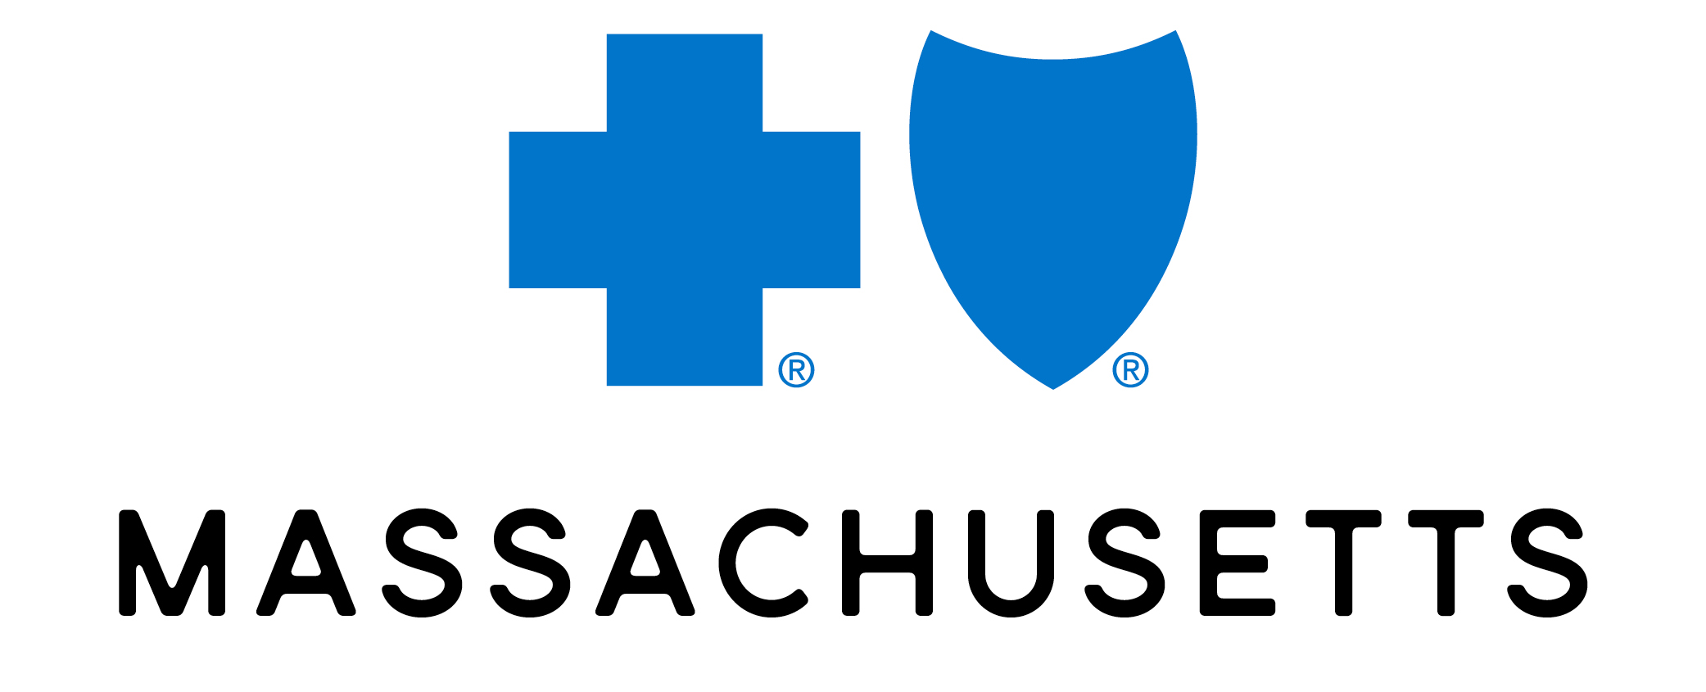

<Name of project/campaign here>

Creative Brief (complex/moderate strategy projects)
Creative Development: Once the Marketing Strategic Brief is reviewed and the Go-to-Market plan is set, each channel/asset that needs to be developed will need Creative Brief that provides Creative Team with asset specific guidelines. You can leverage that information and evolve/update as needed. Attached are all Front Door Intake documents.

Related Campaigns/Projects: (please list names and job#s, including any parent campaigns)
Submitted by: | Submission Date:
Budget: | Desired Delivery Date:

Core team | Which groups/team members are needed to support the project?
  Team | Name  (if known) | Team | Name  (if known) | Team | Name  (if known)
  Business Partner(s) |  | Channel |  | Brand Compliance
  Brand & Consumer Mktg |  | Content |  | Other
  B2B Marketing |  | Creative |  | Other
  Senior Marketing |  | Events |  | Other
  Comp & Benefits |  | Project Mgmt |  | Other
Project Overview | Describe the product, feature, service, or attribute at the core of the project. What is the company trying to achieve? ​ (attached business partner project overview plans as needed)
Target Audience | Who are our market/member segment(s), what do we know about them and why is this relevant to them?  Please include relevant insights (demographics, psychographics, CX insights, NUDGE insights, etc.
Target insight | What is the market/member segment’s current belief?  This should be related to the product or channel you are focusing on, not general beliefs.  After they see this work, what do we want them to think, feel, do?
One Key Message,  CTA & RTBs | WHAT IS THE ONE KEY MESSAGE WE NEED OUR AUDIENCE SEGMENT(S) TO KNOW?  For example: BCBSMA has created a digital navigation experience to help me more easily find mental health care options that are right for me
One Key Message,  CTA & RTBs | What is the CTA? This is our call-to-action. Be specific (URL, 800#, QR code, etc.)  For example: bluecrossma.org : Sign In  We need support for our one key message. Why should consumers believe what we’re saying?  These could be product or brand benefits and attributes.  Please include no more than 3 max and place them in order of priority for emphasis.  If there are multiple audiences, please note if our RTBs differ by audience segment.  1.  2.  3.
Mandatories & Considerations | What must we include? What must we avoid? Are there brand compliance or campaign guidelines to follow?  Are there any legal mandatories? Are there any required channels we need to use to outreach? Are there any creative considerations? (For example – direction to guide image selection)
Best practices | Are there any channel/activity/Nudge Unit best practices to consider?

Project Timeline | What are the key dates we need to hit? (go live for accounts, members, etc.)

