AI work session
Decks and Docs
To Be Placed in Layouts
Deck for Work Session
SLIDE 1 – Holding Slide
Headline: AI/BlueField Working Session
SLIDE 2 –Agenda
Headline:
BlueField: Smarter. Faster. More Creative.
Agenda:
• Welcome
• AI Strategy
• Prompt Like a Pro
• Group Exercise
• Expectations + Next Steps
SLIDE 3 – Our AI/BlueField Strategy
<John, you do not need to add into deck, just here for reference>
This slide pulled from Prem. Sophie and Minita’s deck for EMT: Stated as strategy, but not sure this is strategy. IT’s an approach.

Headline: Humans + AI: Our Winning Formula (Simple Visual Here)
(Section 1: Our Team's Role)
Humans:
We steer the ship.
- We provide the Why: We set the strategy, generate the creative ideas, and use our judgment.
- We bring the Heart: We ensure our work has empathy, tells a story, and connects with our members.

(Section 2: AI's Role)
BF:
The engine that powers us.
- It provides the Speed: AI automates repetitive tasks and analyzes data instantly.
- It provides the Scale: AI helps us personalize content for millions and find patterns we can't see.

(Section 3: The Powerful Result)
Together:
We achieve more.
- Smarter Decisions: We combine our experience with AI-powered insights.
- Faster Results: We free up our team to focus on high-impact, creative work.
- Stronger Connections: We deliver more meaningful and personalized experiences to our members.

Visual cues: ⚙️ Simple triangle or Venn diagram showing “Human + AI = Power”

Summer may want to include (pulled from Association AI Deck):
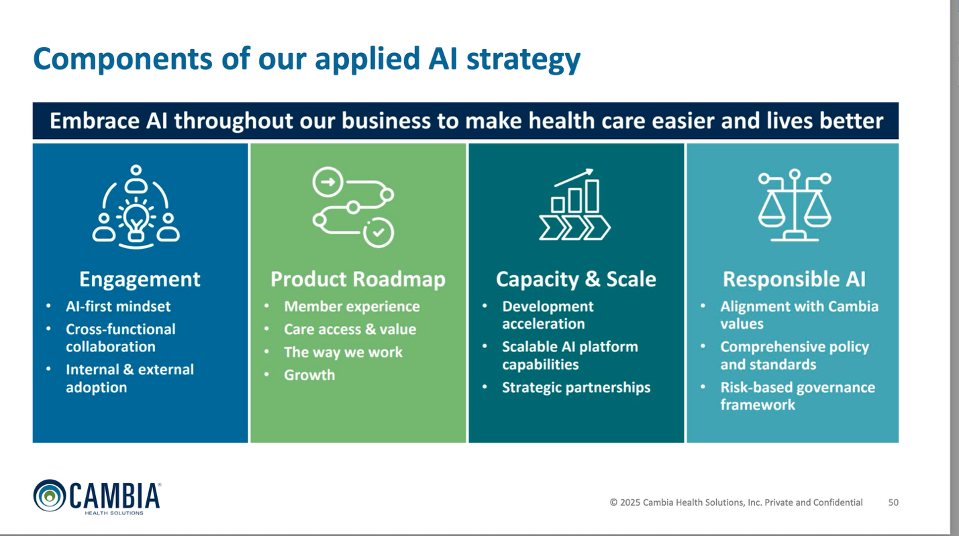
SLIDE 4 – Prompt Framework
Headline: Prompt Like a Pro: Better Prompts = Better Results
The 4C Formula On-screen copy (simple grid or list):
1. Context – What’s this for?
2. Content – What do you want?
3. Constraints – Tone, length, format
4. Call to Action – What should it achieve?
Visual cues: 📊 4-box framework visual

SLIDE 5/or on the side of SLIDE 4 – Prompt Tips
Headline: PRO TIPS: Techniques to Get Even Better Results
Once you're comfortable with the basics, use these to refine your prompts.
- Assign a Role: Tell the AI who to be. This is a powerful way to frame its expertise and point of view.
  - Example: "Act as an expert project manager. Create a checklist for a new product launch."
- Provide an Example (Show, Don't Just Tell): If you want a specific style or structure, give the AI a model to follow.
  - Example: "Here's a sample of a subject line I like: 'Your Weekly Health Digest.' Write five more subject lines in a similar style."
- Iterate and Refine: Your first prompt is a starting point. Treat it like a conversation. If the first response isn't perfect, give the AI feedback and ask for adjustments.
  - Example: "That's a good start. Now, make it more concise and remove the technical jargon."
- Clear > Clever: Avoid ambiguity, slang, or overly complex requests. Simple, direct language works best.

SLIDE 6 – Group Exercise
Headline: Your Turn. Group Exercise.
Break into assigned groups and create: a creative brief + content for the following projects:
1️⃣ Sponsorship Ads
2️⃣ AI Lab Naming
3️⃣ Variable Copay Day 2 Product Naming
Visual cues: 👥 Team icons / breakout bubbles 🧩 “Hands-on AI Lab” subheader for energy

SLIDE 7 – Directions <Keep onscreen during breakout>
Headline: Group Exercise Directions
Time: 25 Minutes
Your Mission: Use Bluefield to create a Creative Brief & generate content for your assigned project. Prepare a 2-minute pitch for your best idea.

The Plan
1. Team Up & Strategize (5 Minutes)
- Find your group members.
- The Team Captain will quickly review the project's goal, audience, and key message, etc.
2. Prompt & Create (15 Minutes)
- Start prompting in Bluefield using your project's objective.
- Remember the Prompting 101 rules: 4Cs.
- Work together to refine your prompts and explore different creative options.
3. Choose & Pitch (5 Minutes)
- As a team, select your single best BlueField-generated idea.
- Prepare to share your idea and explain why it's the right choice in a quick 2-minute pitch.

Slide 8: Team Readouts
Headline: Team Readouts
Time: 2 Minutes Per Group
1. Present Your Big Idea
- Briefly describe the concept you created with AI. What is it and who is it for?
2. Share Your Experience
- ✅ What Worked? (What was a quick win or a pleasant surprise?)
- ⚠️ What Felt Off? (Where did you get stuck or find a challenge?)
3. Give Your #1 Prompting Tip
- 💡 What is the single most important tip you would give to the group?
SLIDE 7 – Wrap-Up
Headline: AI = Your Creative Partner
Our Path Forward:
- Start Small then Scale: Begin with manageable AI tasks and grow from there.
- Always Edit for Brand Voice: You are the expert. Use AI as a tool, but ensure every output meets our brand standards.
- Track & Measure: Aim to use Bluefield at 1X a day and log your usage in Workfront. This data is crucial for showing us where we're saving time and what projects benefit most.
- Share Wins & Learnings: Let's learn from each other's successes and challenges.

Larger type across bottom: Aim to use Bluefield at 1X a day

Instructions for Group Exercise: Print out/version adapted for screen:
🧠 AI Team Challenge: Creative Brief + Content
Goal: Use AI to turn strategy into creative briefs + first draft of content for xxx
1️⃣ Form Your Group
• Gather at your assigned table.
• Captain will log into BlueField
2️⃣ Review Your Project
Your team will work on one of the following: outline which teams get which projects?
1. Sponsorship Ads
2. AI Naming Lab Email
3. [Project XXX]
3️⃣ Align on the Strategy
• Review the provided insights/marketing strategy.
• Define your audience, message, and goal.
4️⃣ Write Your Creative Brief
Use BlueField to take marketing strategy and write a creative brief.
Keep it tight — upload into Creative Brief template.
Include:
• Objective
• Target Audience
• Key Message
• Tone/Voice
• Call to Action
5️⃣ Prompt the AI
The Captain enters a clear prompt using your brief.
💡 Example: “Write a promotional email for [project]. Target [audience], tone [style], focus on [message]. Include subject line, headline, body, and CTA.”
6️⃣ Review + Refine
• Review BlueField’s draft.
• Edit for tone, clarity, and brand voice.
• Make it something you’d actually use.
7️⃣ Prepare to Share
You’ll present:
✅ Your creative brief
✅ Your AI-generated email draft
✅ One takeaway or “aha” from using AI
Time limit: 25 minutes Goal: Collaborate. Create. Share
BlueField Group Exercise Captain Guide
Your Part: Lead your group through the AI/BlueField Work Session Breakout.
You’re the pilot—BlueField is your co-pilot.
Pre-Meeting: We’ll set you up for success
- Access to AI Task Force Folder
- Upload documents (including templates, brand guidelines, ad examples) into BlueField

During the Meeting:
1️⃣ Set the Tone: Kick off with energy: “Let’s see what BlueField can do with us—not for us.”
• Make sure everyone has a voice—this is a group effort.
2️⃣ Start Prompting: You’re in the driver’s seat!
Keep your group aligned and focused on your 2 deliverables:
• Creative Brief: Using Marketing Strategic inputs, write a creative brief, make sure to prompt BF
to use the uploaded Creative Brief template
Template
• Content for one of the following:
-Sponsorship Ad
-AI Lab Naming
-Variable Copay Day 2 Product Naming
Reminders for Great Prompting 4 Cs
1. Context – What’s this for?
2. Content – What do you want?
3. Constraints – Tone, length, format
4. Call to Action – What should it achieve?
3️⃣ Ideate – Write Creative Brief + Content for your Project
Tips:
• Invite ideas quickly—no overthinking.
• Read the AI output aloud and edit together.
• Remind them: AI is fast, but our human judgment is what makes it brand appropriate.
4️⃣ Consolidate + Delivery
Before time’s up, make sure your team can share:
✅ Creative brief
✅ Content for your project
✅ 1 key takeaway or “aha” moment
Captain Mindset
🧠 Curious 💬 Collaborative ⚡ Confident
You’re not just leading a table—you’re showing how BlueField I and human creativity work better together.

PDF Takeway:

Appendix/older copy:
Slide 1: Welcome to the AI Era
Header: Smarter. Faster. More Creative.
Body:
• Today we’ll unlock how to use AI to amplify our marketing power.
• Think assistant, not replacement.
• Let’s build confidence—and creativity—with AI.
Slide 2: Our AI Strategy
Header: AI: Our Competitive Edge
Body:
• Accelerate content creation
• Boost personalization and insights
• Free time for big ideas Tagline: Human creativity + AI efficiency = impact.
Slide 3: Prompt Like a Pro
Header: Garbage in → Garbage out
Body:
• Clear > Clever
• Context is everything
• Specify tone, format, and audience
Example: ❌ “Write an email” ✅ “Write a 3-line intro email to C-suite sponsors, warm tone, focus on partnership value.”
Slide 4: Prompt Framework
Header: The 4C Prompt Formula Body:
1. Context – What’s this for?
2. Content – What do you want?
3. Constraints – Tone, length, format
4. Call to Action – What should it achieve?
Mini Tip: Treat prompts like creative briefs—specific wins.
Slide 5: Group Exercise
Header: Your Turn to Play Body: Break into 3 groups. Create:
1. Sponsorship ads
2. AI Naming Lab email
3. [Project XXX] Goal: Draft a creative brief + first pass email copy using AI.
Slide 6: Team Readout
Header: Show. Don’t Tell. Body:
• Each group presents their AI-assisted brief + email
• Discuss: What worked? What felt off?
• Share top prompt tips
Slide 7: Wrap-Up
Header: AI Is Your Creative Wingman
Body:
• Start small → Scale smart
• Always edit with your brand voice
• Share wins + learnings
Tagline: We’re better—and faster—together with AI.
Xxxxx

For one pager:
Slide Title: How to Talk to AI: A Guide to Effective Prompting
Core Idea: The quality of your prompt directly determines the quality of the AI's response. Think of it as giving clear, specific instructions to a new team member.

1. The CORE FOUR: Must-Haves for Any Good Prompt
These are the fundamental building blocks. Start here, every time.
Practice | Why it Matters | Example
1. Start with a clear ACTION | Tells the AI exactly what to do. | Write an email... Summarize this report... Brainstorm five names...
2. Add CONTEXT | Gives the AI the background it needs to understand the "why" behind your request. | "I'm preparing for a client meeting..." "This is for a new hire onboarding packet..."
3. Specify the AUDIENCE | Defines who the final output is for, which shapes the language and complexity. | "...for an audience of senior leaders." "...for members who are new to our plans."
4. Define the TONE & FORMAT | Controls the feeling of the response and how it's structured. | "Use a friendly and encouraging tone." "Put the final answer in a table."

2. PRO TIPS: Techniques to Get Even Better Results
Once you're comfortable with the basics, use these to refine your prompts.
- Assign a Role: Tell the AI who to be. This is a powerful way to frame its expertise and point of view.
  - Example: "Act as an expert project manager. Create a checklist for a new product launch."
- Provide an Example (Show, Don't Just Tell): If you want a specific style or structure, give the AI a model to follow.
  - Example: "Here's a sample of a subject line I like: 'Your Weekly Health Digest.' Write five more subject lines in a similar style."
- Iterate and Refine: Your first prompt is a starting point. Treat it like a conversation. If the first response isn't perfect, give the AI feedback and ask for adjustments.
  - Example: "That's a good start. Now, make it more concise and remove the technical jargon."
- Clear > Clever: Avoid ambiguity, slang, or overly complex requests. Simple, direct language works best.

Your Go-Forward Mission: Practice & Experiment!
- Start Small: Begin with simple, low-stakes tasks like summarizing an article or brainstorming ideas.
- Build on Success: Once you get a result you like, save that prompt as a template for future use.
- Don't Give Up: If a prompt doesn't work, try rephrasing it using the tips above before starting over. Small changes can make a big difference.

Alt ideas for prompting slide:
1. ACTION: What should it do?
- Examples: Write, Summarize, Brainstorm, Translate
2. CONTEXT: What's the background?
- Examples: "For a client meeting," "For a new hire packet," “For an B2C email”
3. AUDIENCE: Who is it for?
- Examples: Senior leaders, New members, Brokers & Consultants
4. FORMAT: How should it look and sound?
- Examples: An email, A table, A bulleted list, A friendly tone

XXXXXX
Deck last page: Tagline across the bottom: Create. Collaborate. Accelerate.
SLIDE 8 – Next Steps
Headline: Making BlueField Part of Our Daily Toolkit
On-screen copy:
• Use AI for first drafts + brainstorming
• Follow brand + compliance guidelines
• Keep experimenting + sharing prompts CTA: Let’s make marketing move faster—with purpose. Visual cues: 🛠️ Toolkit or workflow icons ✅ Animated checklist

